# QlikView Dashboard and Understanding

Yaaseen Gamieldien

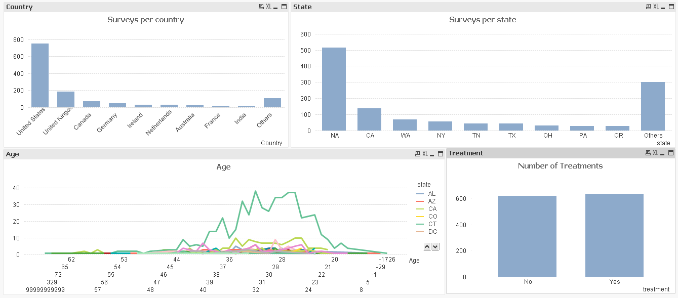

The purpose of this dashboard is to narrow down where exactly the most treatments of employees had taken place after inspection I filtered it down to this:

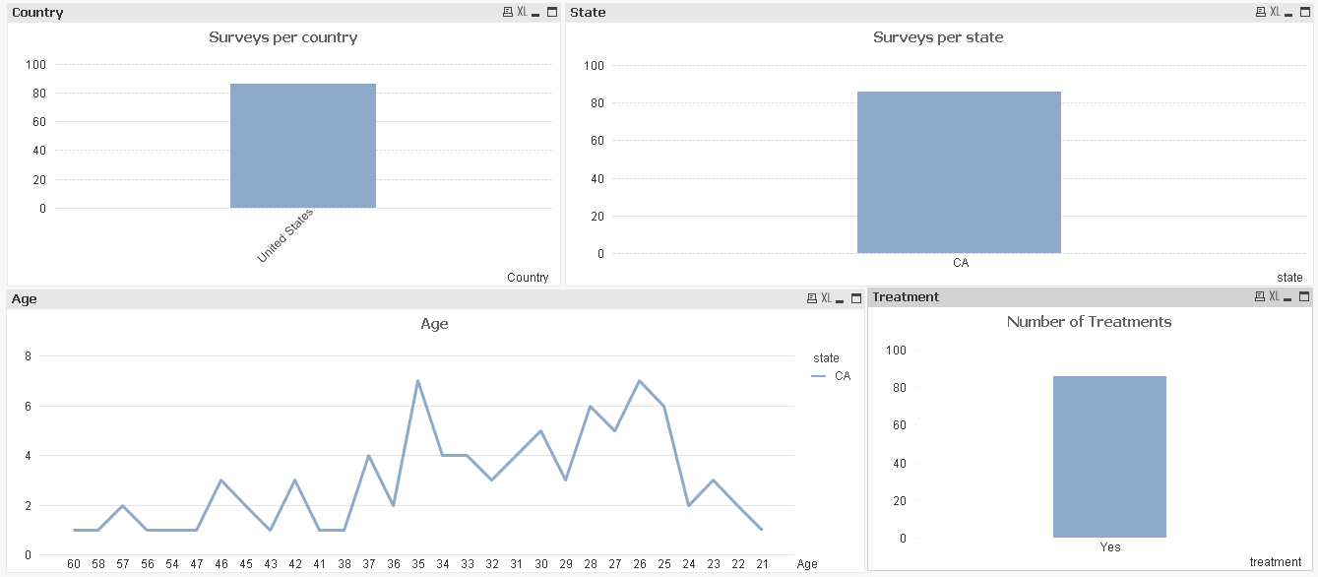

As you can see the state with majority surveys were done in the United State and in the state of California. The Age of people that most treatments were performed on were 35 and 26.

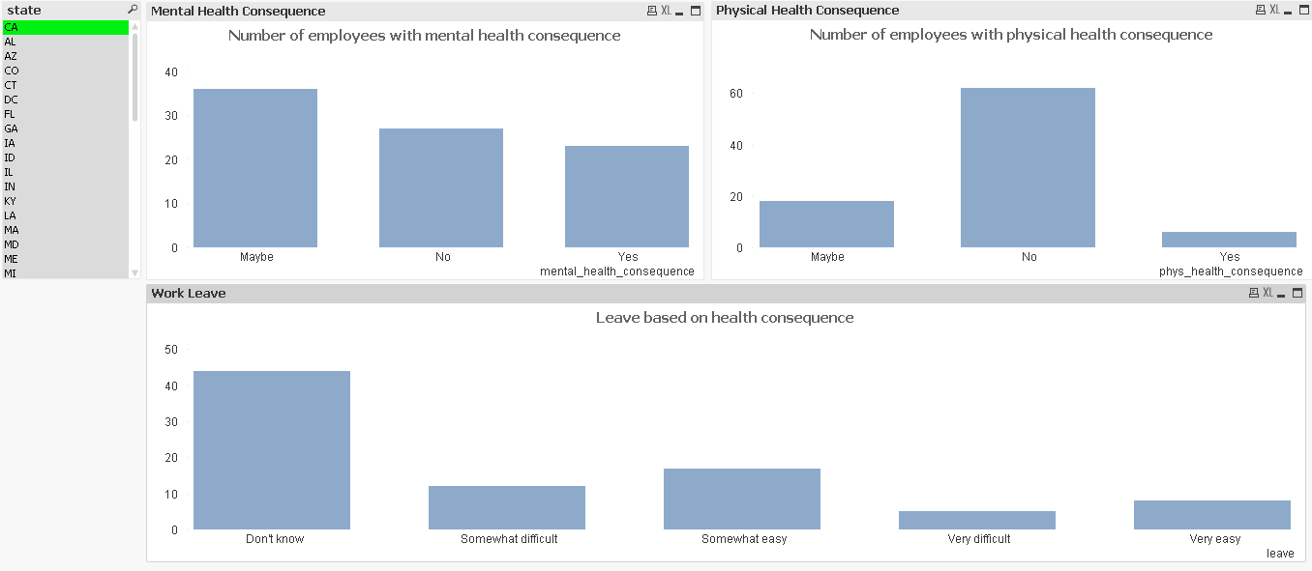

So now that it has been narrowed down to California. I wanted to look at the relationship between mental and health consequence, and the difficulty it was for those employees to take leave.

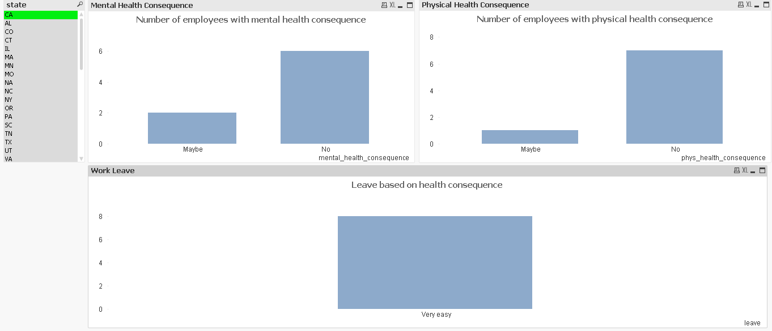

For the employees that found it very easy to take leave, none of them were found to have any mental or physical consequences whereas:

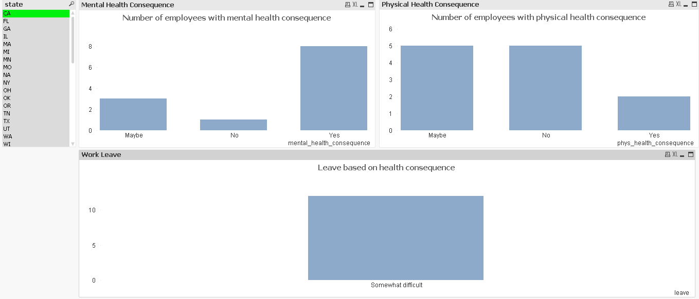

People that found it somewhat difficult to take leave were found to have mental and physical consequence.